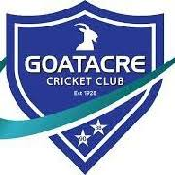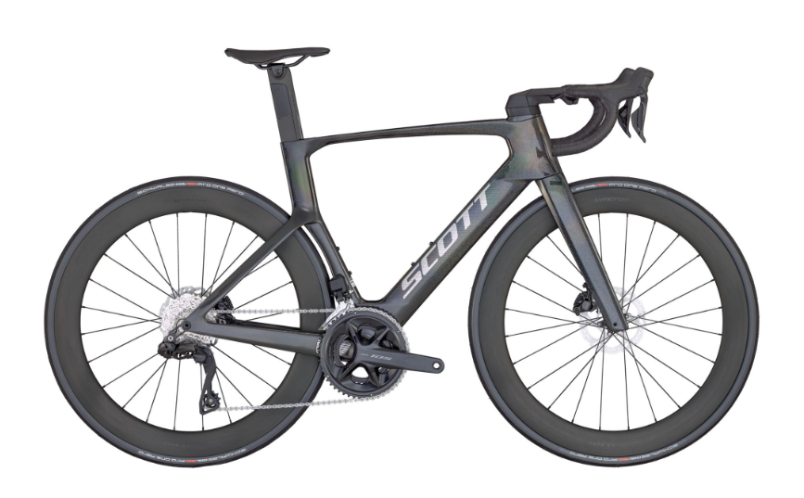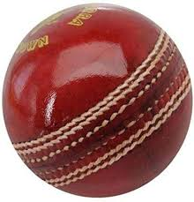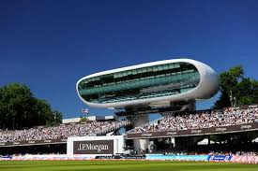

Goatacre CC Marathon Bowl To Lord’s Sponsorship Form
As cricket becomes more expensive to run, fundraising is vital.
On Saturday 28th March 2026 GCC players, committee members and supporters are taking part in a marathon bowl to match the distance from Goatacre CC to Lord’s (91.3 miles) which equates to 7,304 balls in our nets!
At the same time, three GCC members will be cycling from Lord’s back to Goatacre. Who will finish first?!
Please sponsor me as I help raise funds for my club.
The member who raises the most in sponsorship will receive 2 tickets for a major cricket match in 2026.
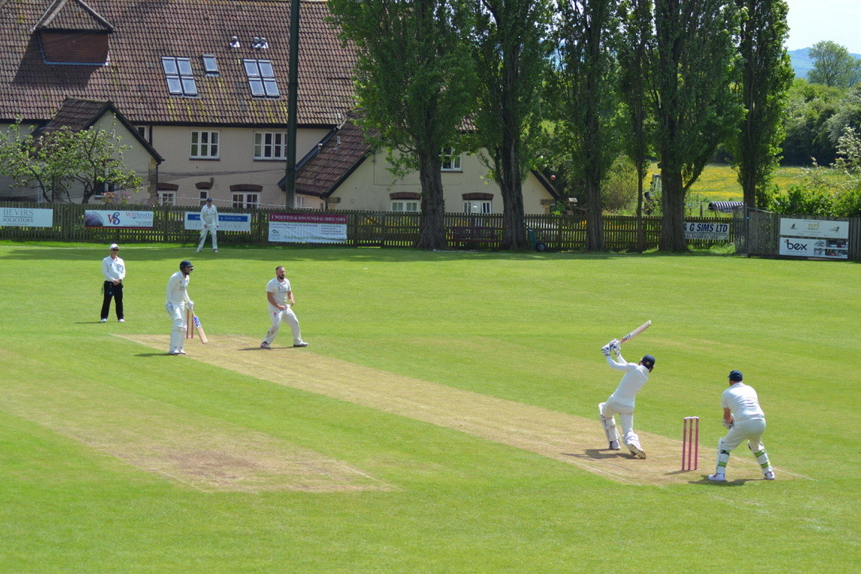

Sponsor Name | Address | Amount Sponsored | Paid (Y/N)
Thank you for your generous support – every donation helps keep Goatacre CC thriving!
We are inviting everyone to come and join us from 8am on Saturday 28th March as the marathon bowl takes place. There will be a BBQ and refreshments available and all are welcome!

